Microsoft SQL Server Report Pack for Financial Reporting
The Report Pack for Financial Reports is a set of predefined report definition files that demonstrate common financial reports which work with the Financial Sample Database called FinSampleDB. You can upload and view each report separately; however, some reports are designed to work together through the use of links. You can use the sample reports as templates for designing new reports. The following table describes the sample reports that are provided in this Report Pack.
Report | Description
Balance Sheet | Fabrikam Works Inc. Balance Sheet by Fiscal Year and Current Period. This report illustrates the use of a table to group Account Balances to emulate a standard Balance Sheet.
IncomeStmtCurYTD-Company | Fabrikam Works Inc. Income Statement for the current month and YTD by Company, Fiscal Year, and Current Period. This report includes a table to display income statement line items and also displays drilldown features.
IncomeStmtCurYTD-Region | Fabrikam Works Inc. Income Statement for the current month and YTD by Company, Fiscal Year, Current Period, and Region. This report includes a table to display income statement line items and also displays drilldown features. Parameters allow you to filter by different dimensions.
IncomeStmtTrended | Fabrikam Works Inc. Income Statement by Company, Fiscal Year, and trended over periods. This report includes a matrix to display trends of different line items in an income statement. It also includes a chart that graphs Revenues trended over periods, which can be set with parameters. Drilldown, as well as drillthrough features are also present.
Trial Balance | The trial balance is an arithmetic check of the double entry system. It is checking that both aspects of every transaction have been recorded accurately; that for every debit entry there is an equal value for its corresponding credit. The trial balance provides figures for the balance sheet including assets and liabilities.
Variance Report | The Variance Report contains actual, budget, and variance information for Fabrikam, Inc. Variances are calculated by taking Budget – Actual for Expense items and Actual – Budget for Income items on the report. This report is sorted in descending order and negative variances highlighted to aid the business community to identify which income statement line items have the largest absolute dollar value variance in the current period.

System Requirements
Your system must meet the following requirements to install and use the sample reports.
Server
· Microsoft SQL Server™ 2005 (for installing the sample database)
· Microsoft SQL Server™ 2005 Reporting Services
Client
· Microsoft Internet Explorer 5.5 or later
· Microsoft Visual Studio® 2005 with Report Designer installed (for uploading or modifying the reports)
Disk Space
· Sample Database: 27.3 megabytes (MB)
· Sample Reports: 271 kilobytes (KB)

Installing the Financial Report Pack
- Launch SQL2005RPFIN.MSI and install the contents to a destination of your choice.
- Attach the database and upload the reports as described in the following sections.
Attaching the FinSampleDB Database
- Open SQL Server Management Studio. On the Start menu, point to All Programs, point to Microsoft SQL Server 2005, and click on SQL Server Management Studio.
- Connect to the SQL Server where you want to install the sample database.
- Navigate to the Databases folder.
- Right-click the Databases folder, click Attach….
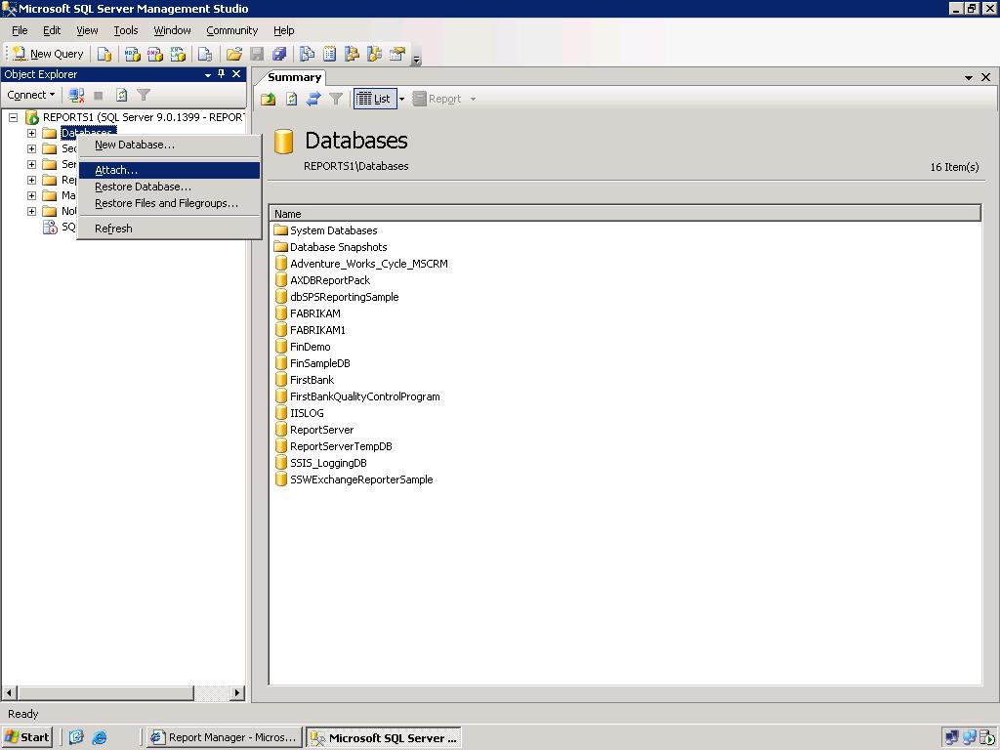

- In the Attach Databases window, click the Add button, navigate to the folder that contains the report pack files, and select the FinSampleDB.mdf file. Then, click OK.
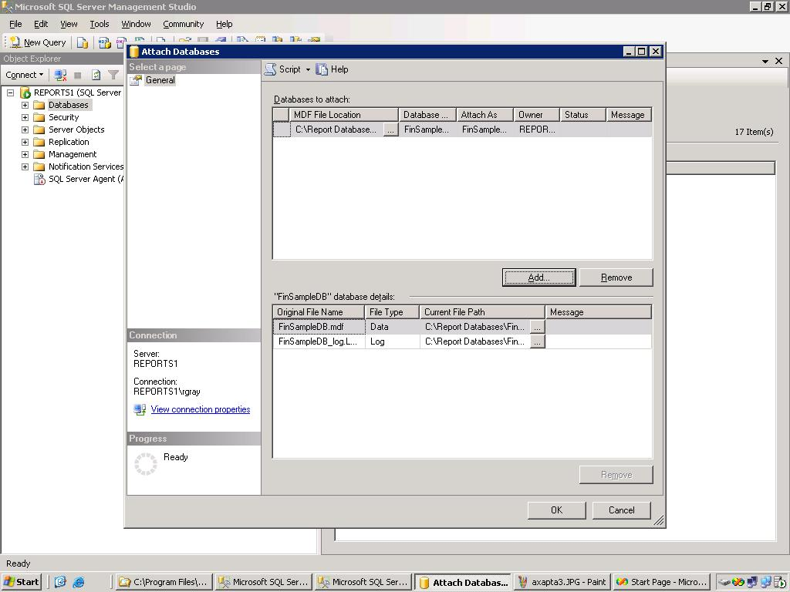

Uploading the Sample Reports
To make the sample reports available for viewing in a Web browser, you must upload the report definition files to the report server using Report Manager or Report Designer in Business Intelligence Development Studio.
Option 1: Publish sample reports using Report Designer
- Open SQL Server Business Intelligence Development Studio. On the Start menu, point to All Programs, point to Microsoft SQL Server 2005, and click on SQL Server Business Intelligence Development Studio.
- Click on File and select Open Project. Navigate to the folder where the Report pack contents have been extracted. Open the sample report project.
- By default, the reports will be published to a local report server at the URL http://localhost/reportserver. If you would like to change this location you can do this by selecting Properties from the Project menu.

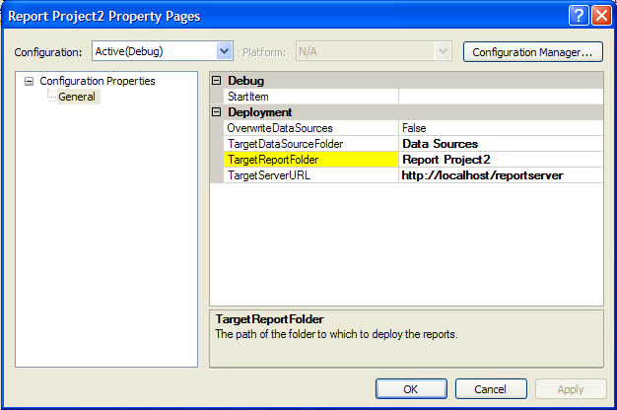

- Publish the reports by clicking Deploy Financial Report Pack from the Build menu.

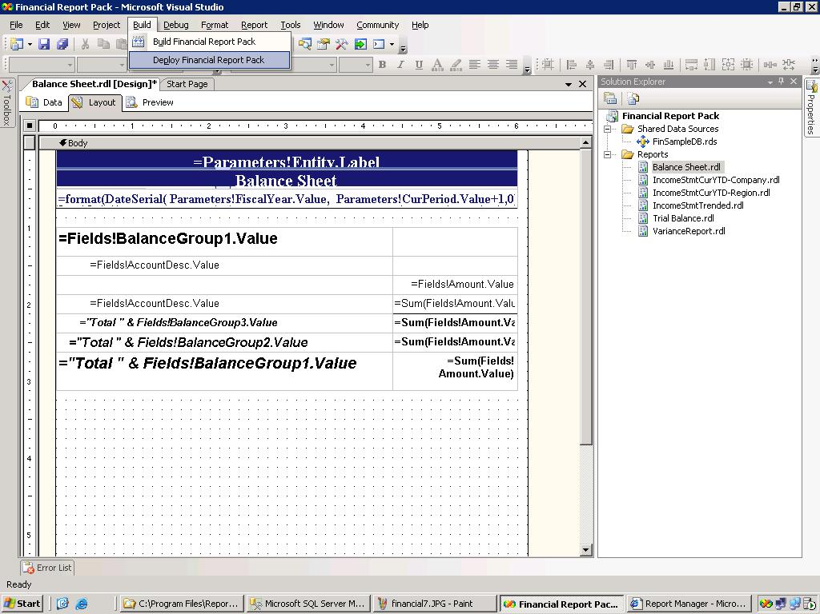

Option 2: Upload sample reports using Report Manager
Note: To create a data source and upload files to a folder on the report server, you must have permissions to manage reports for the folder. For more information, see Managing My Reports .
- Navigate to Report Manager in your browser. By default, the URL is http://<webservername>/reports.
- Create or Navigate to the destination folder for uploaded reports. For more information, see Navigating Folders in Report Manager .
- Click New Data Source, and then do the following:

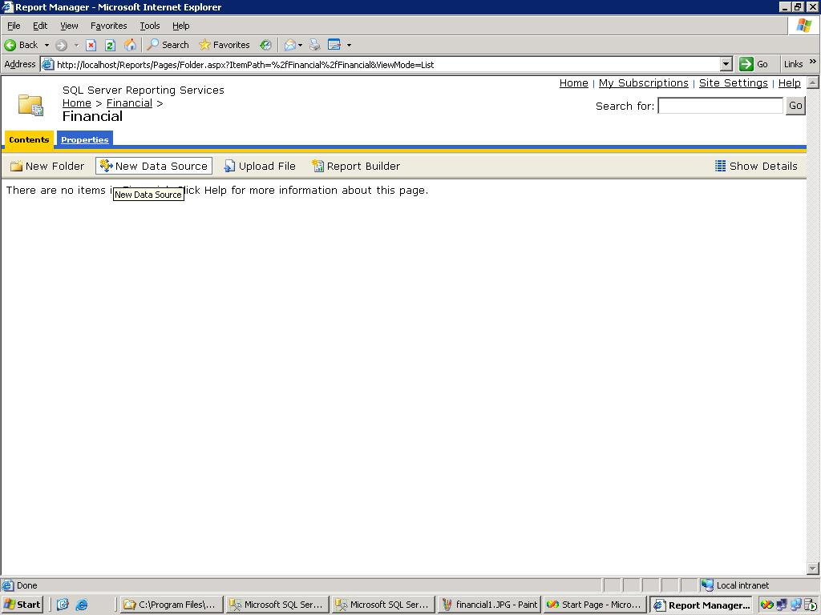
  - In Name, type Financial Data Source. The reports reference the data source by this name.
  - In Description, type a description or leave the field blank.
  - From Connection Type, select Microsoft SQL Server.
  - In Connection String, provide the connection string to the database that contains the FinSampleDB data. An example of the connection string for a local sample database is: data source=(local);initial catalog=FinSampleDB;
  - Under Connect Using, select Windows NT Integrated Security or the appropriate database credentials.

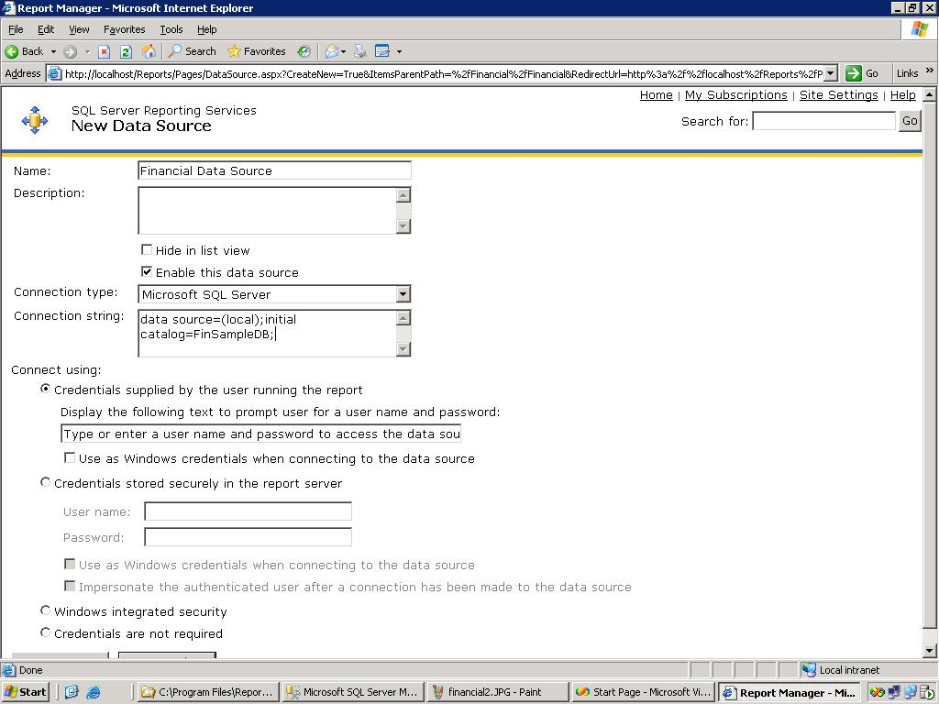

- Click OK to save the data source and return to the folder view.
- Click Upload File, and then click Browse to navigate to the folder that contains the reports.
- Click the file to upload, and then click Open.
- Click OK to open the file.

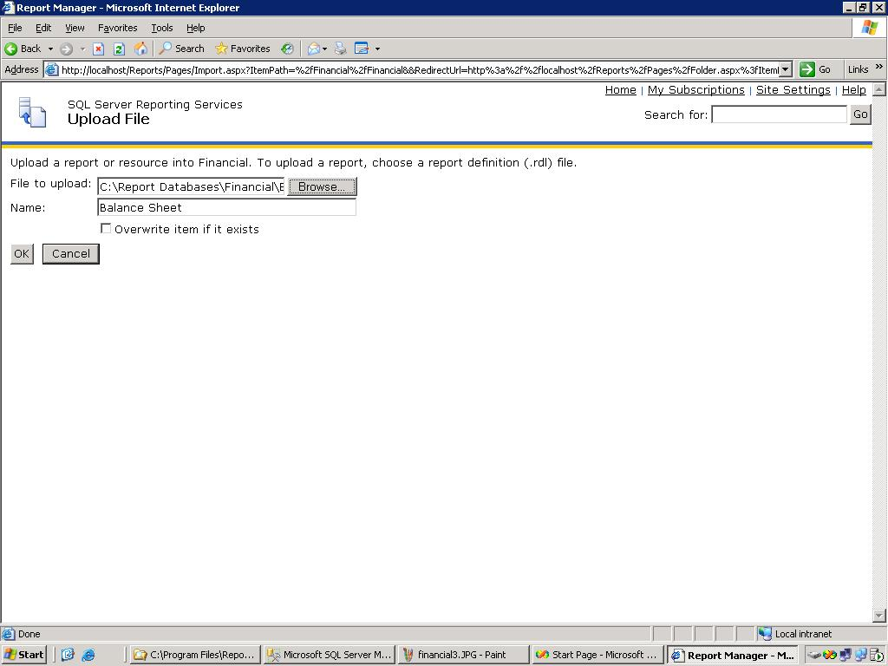

- Repeat steps 5 through 7 for the remaining sample reports.
Point reports to correct Data Source
- Click on one of the reports uploaded in the previous section.
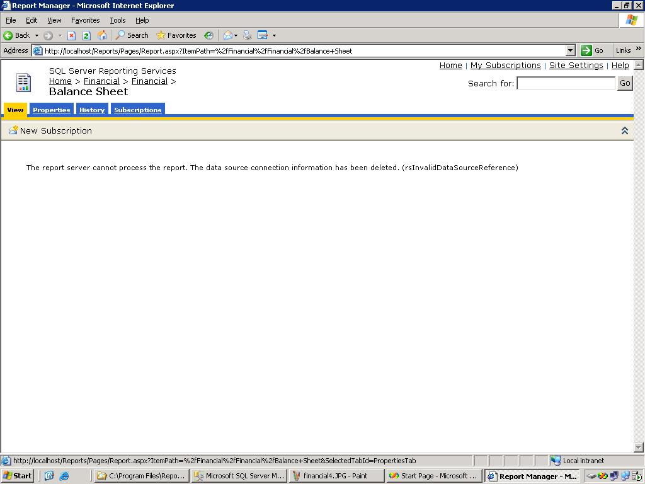
- Click on the Properties tab
- Click on Data Source in the menu on the left
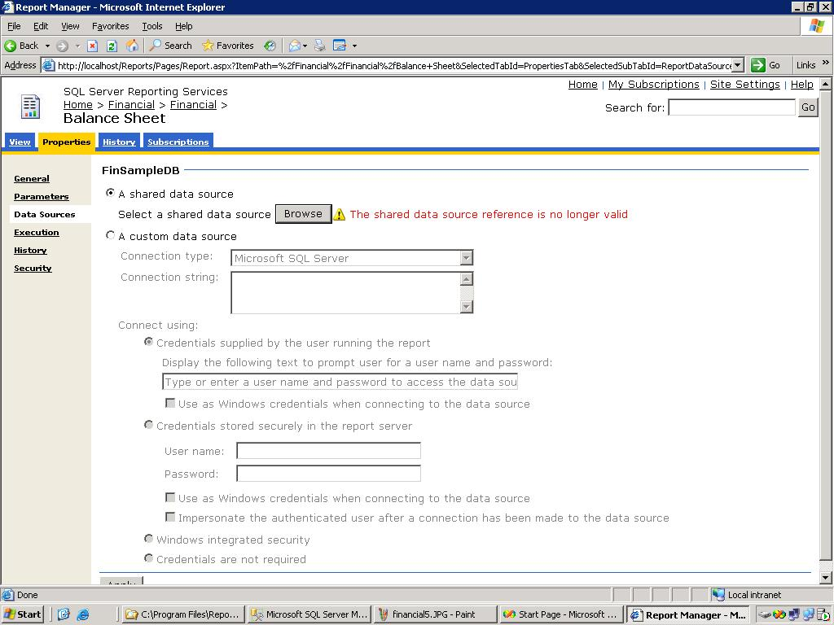

- Click Browse and navigate to the Data Source created for these reports.
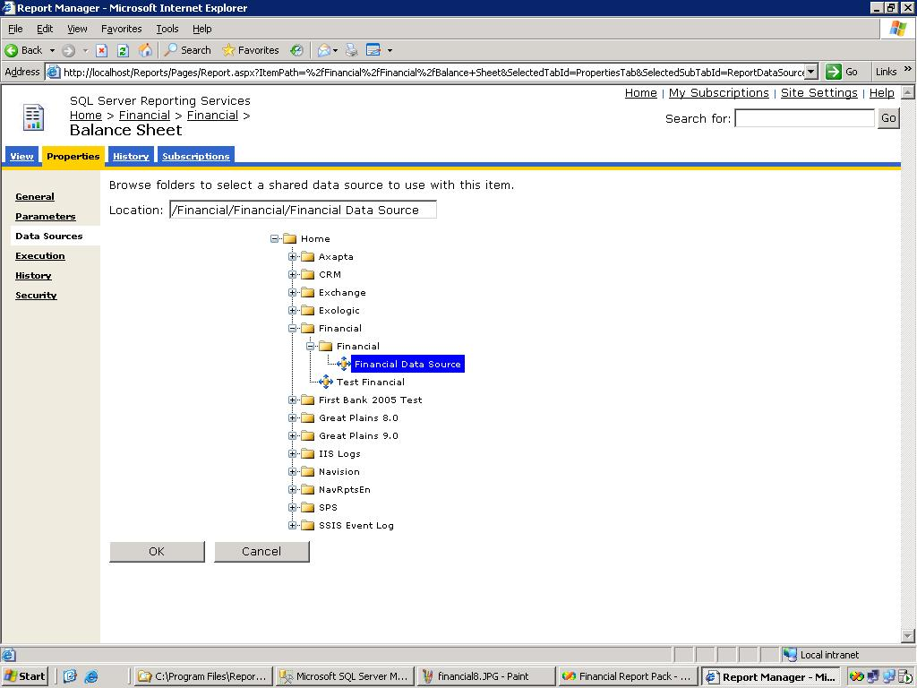
- Click OK to return to the previous screen and then click Apply at the bottom.
- Repeat steps 1 through 5 for the remaining reports.

Using the Sample Reports
You can view the sample reports in a Web browser or edit them in Report Designer. Before you runt the reports, ensure that the FinSampleDB database is available to the reports and confirmed that the user has full read access to all views and tables in that database.

View sample reports using Report Manager
- To run Report Manager, type its URL in the address bar of a Web browser. By default, the URL is http://<webservername>/reports.
- Navigate to the folder that contains the reports.
- Click the name of the report that you want to view to open it.

